|  |  |
| --- | --- |
| Power BI Lab Day 7 Document | |
|  |  | | |
| **Writer:** | I&D Microsoft | | **Initials entity:** |
| **Date creation:** 28/04/2018 | |  | **Last upgrade:** 28/04/2018 |

Power BI LAB DOCUMENT

DAY 7- Lab 2

|  |  |  |  |  |
| --- | --- | --- | --- | --- |
| Version | Author | Comment | Reviewed By | Date |
| V 1.0 | I&D Microsoft | Initial draft | Moupiya Das |  |
|  |  |  |  |  |
|  |  |  |  |  |

**Pre-requisites**

Installed and working Power BI Desktop setup.

**Environment Setup**

To install Power BI Desktop to your machine or to sign up for Power BI Service, Refer to Power BI Lab Exercise Day 1.

**Lab Overview**

This lab comprises of five tasks:

1. To Create a Dynamic Measure

**Case Scenario**

The AdventureWorks Database is a sample database file which supports a fictitious, multinational manufacturing company called Adventure Works Cycles. The AdventureWorksdatabase excel sheet has 27 different sheets in total.

We will be importing 3 sheets to perform the various tasks in the Lab. We need to create an optimized data model using Power BI Desktop in order to achieve the desired results. To accomplish this, we would be focusing on the relationship View, measures, calculated tables and columns and various other options that would help us get a better insight of the data.

# Table of Contents

Table of Contents 3

1. Import Data 4
2. Transform & Visualize Data 6
3. Data Optimization 8

# 1. Import Data

1. Start with a blank Power BI Desktop file.
2. Click on Get Data option in the ‘Home’ tab and choose Excel.

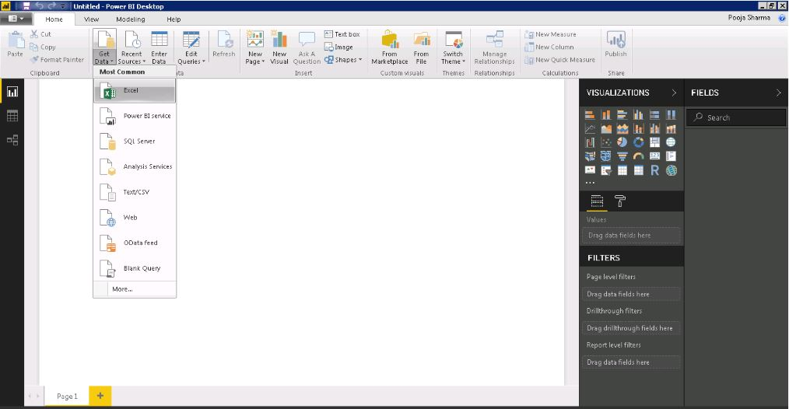

1. Select AdventureWorksDatabase, from the browse menu and click Open.

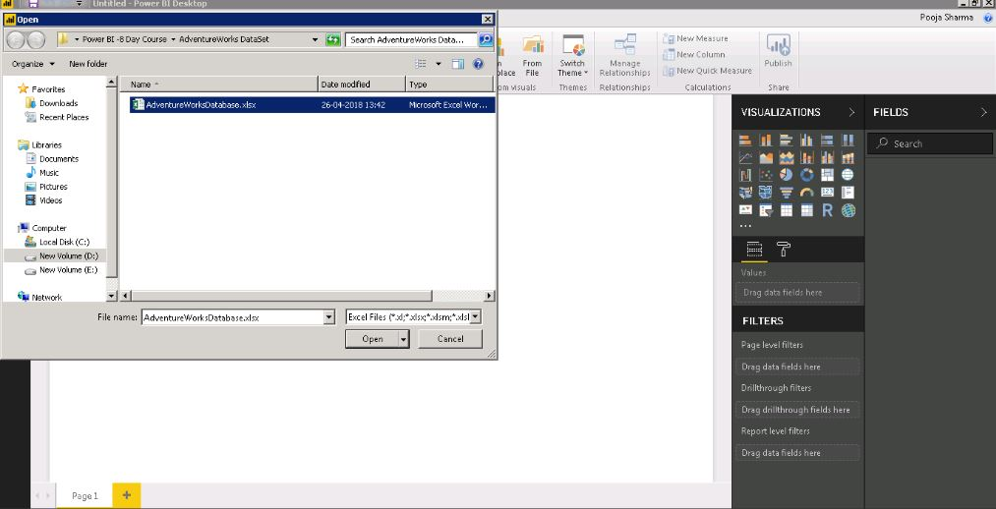

It would take a little time to connect to your database.

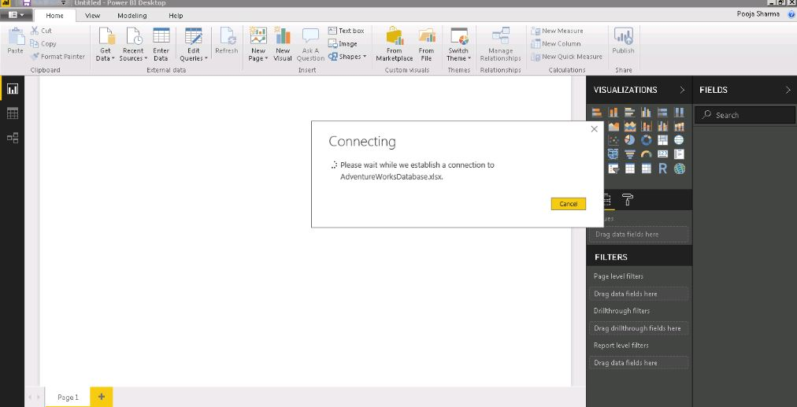

1. From the Navigator menu, select the four table i.e DimDate, FactSalesQouta and FactInternetSales and then click ‘Load’.

# 2. Transform & Visualize Data

1. From the Relationships View, select Manage Relationships.

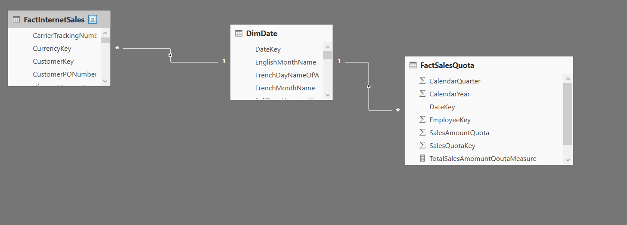

1. In the Edit Relationship dialogue, change the cross filtering direction from Single to Both.
2. In the Data view Pane, select ‘New Column’ to create a calculated column in table FactInternetSales.

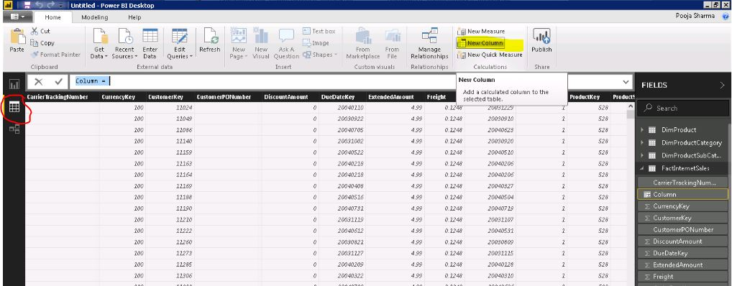

1. Use formula: TotalPrice = FactInternetSales[OrderQuantity]*FactInternetSales[UnitPrice] and hit Enter.
2. Add Measure called TotalPriceMeasure = CALCULATE(SUM(FactInternetSales[TotalPrice])) in FactInternetSales table
3. Add Measure called TotalSalesAmomuntQoutaMeasure = CALCULATE(sum(FactSalesQuota[SalesAmountQuota])) in FactSalesQouta table
4. Add a Table called DynamicMeasure from Modelling tab and name column as Dynamic Measure and add 2 rows in it called TotalPrice and SalesAmoutQouta

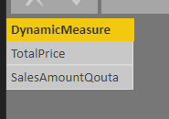  
  
And add a Measure called   
Measure=IF(lastnonblank('DynamicMeasure'[DynamicMeasure],"")="TotalPrice",[TotalPriceMeasure],if(lastnonblank('DynamicMeasure'[DynamicMeasure],"")="SalesAMountQouta",[TotalSalesAmomuntQoutaMeasure],0))

# 3. Data Optimization

1. Add a slicer and drag DynamicMeaure Field into it.
2. Then add a Line Chart and drag Fiscal Year field into it from dimDate table and drag Measure field from DynamicMeasure table into values field
3. So as soon as you change the selection in Slicer the Measure field in the visualization will change.

